Dear All,

Middlesex Section have been invited to bring our cars to a very special gathering to celebrate the Queen’s Platinum Jubilee
on Saturday 4th June at Ashridge House. Those of you who have booked a place on our April Road Run will see this magnificent
house with its historic grounds and a return visit will be just the thing for the Jubilee weekend. RREC cars will have spaces in the Reserved Parking
facing the house.

If you would like to join us, please complete the attached form and return it to Holly Edwards, Public Events, 01442 843491, tickets@ashridge.hult.edu
The cost is just £20 per car.

Kind regards,

David

David Siegal
RREC Middlesex Section Treasurer and Membership Secretary
07973-518421

Best of British Car Show at Ashridge House
Saturday 4th June 2022

Car Owner Information
THE EVENT
Ashridge House will be hosting The Best of British Car Show on Saturday 4th June 2022 on the North Lawn facing the front of Ashridge House.
As a former royal residence, Ashridge House provides the perfect back drop for a whole host of British cars to get together on the Jubilee weekend to celebrate the 70th year of Her Majesty, the Queen’s rein.

VENUE
On our North Lawn at Ashridge House www.ashridgehouse.org.uk (map attached).

Ashridge House
Berkhamsted
Hertfordshire
HP4 1NS

(Parking directions as given below)

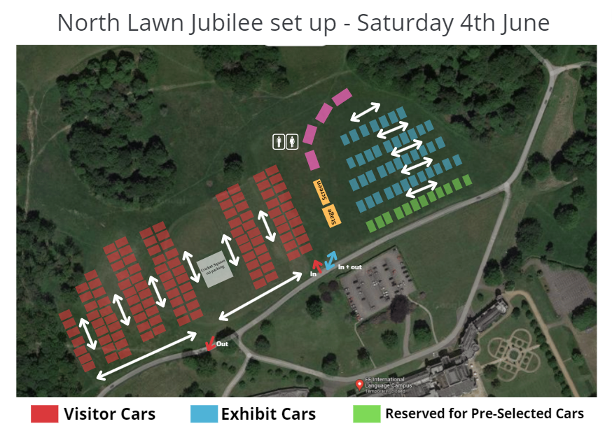

TIME
Arrive: 9:30am - 10:30am
Event: 11:00am - 4:00pm
Leave: 4.15pm – 5:00pm

RESERVATION
In order to reserve a place, we require an upfront, non-refundable payment of £20.00. Please first complete the Application Form on the last page of this document and email it to the Events Department at Ashridge House - tickets@ashridge.hult.edu. Once your application form has been processed, we will ask for you to make payment via BACS.
Please note that 50% of your reservation payment will be donated to our local charity partner: The Hospice of St Francis (https://www.stfrancis.org.uk).
The Hospice of St Francis is a charity that helps 2,000 local people and their families, in Hertfordshire and Buckinghamshire, to enhance and live their precious lives well through improving symptoms, achieving personal goals and helping them feel safe.

TERMS
- British Car Qualifications
Given that this is an event celebrating the history of British Cars, we ask that vehicles are of a British heritage at time of manufacture.
- Vehicle movement
Given the large public spectator levels expected at this event, there is to be no movement of exhibited vehicles between the times of 11:00am and 4:00 pm. Therefore, please arrive before and leave after those times, otherwise you may be required to park in the public car park.
The only exception to this rule will be for preselected cars that have been chosen to do a presession at various points throughout the day.
- Inclement weather
Ashridge House will not be liable for any delay in performing its obligations or cancelling the event as a result of any act, event, omission or accident beyond the reasonable control of Ashridge House including without limitation flood, storm, adverse weather condition, natural event, fire, act of God, act of government, compliance with any change to law and interruption or failure of utility or service.
- Commercial endorsement or activity
We do not permit car or merchandise sales at this event.

LIABILITY
EF Corporate Education Limited (t/a Ashridge House) cannot accept any liability for any damage sustained to vehicles whilst on the grounds of the house.

REFRESHMENTS
There will be a selection of hot and cold food and drinks on offer from a selection of vendors.

TOILETS
Toilets will be available on site.

REFUSAL OF ADMISSION
We reserve the right to refuse admission or require you to leave the premises without a refund if you:
1. behave in an anti-social or threatening manner; or
2 put the safety of our customers, our employees or our property at risk.

CONTACT

Holly Edwards, Public Events, 01442 843491, tickets@ashridge.hult.edu

BEST OF BRITISH CLASSIC CAR SHOW APPLICATION FORM

Personal Information:
Contact name: …………………………………………………………………………………………………………………………..
Contact number: ……………………………………………………………………………………………………………………….
Contact email address: ……………………………………………………………………………………………………………..

Vehicle Information:
Make of the vehicle: ………………………………………………………………………………………………………………..
Exact model: ……………………………………………………………………………………………………………………………
Year: ………………………………………………………………………………………………………………………………………..
Registration Number: ………………………………………………………………………………………………………………

I am attending with a car club please place us together (if possible):
Yes
No
Name of Car Club: ………………………………………………………………………………………………………………………

Please return a completed copy of this form to the Events Department at tickets@ashridge.hult.edu and we will be in touch regarding the payment process.

