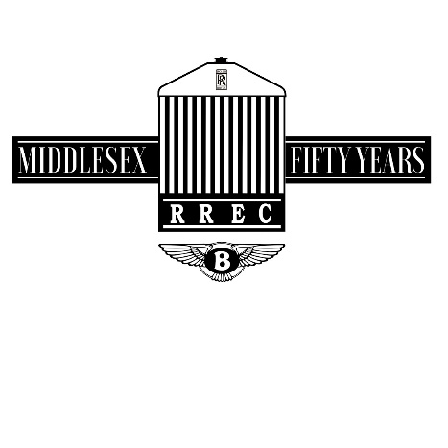

Middlesex Section Pub meet, 2nd Tuesday of the month
Now that the evenings are longer, we are resuming our pub meets on the second Tuesday of each month starting on 12th April at THE COWPER ARMS, Cole Green Hertfordshire.SG141NL, telephone 01707 330202. This country pub is located just half a mile south of the A414 between Hertford and Hatfield.
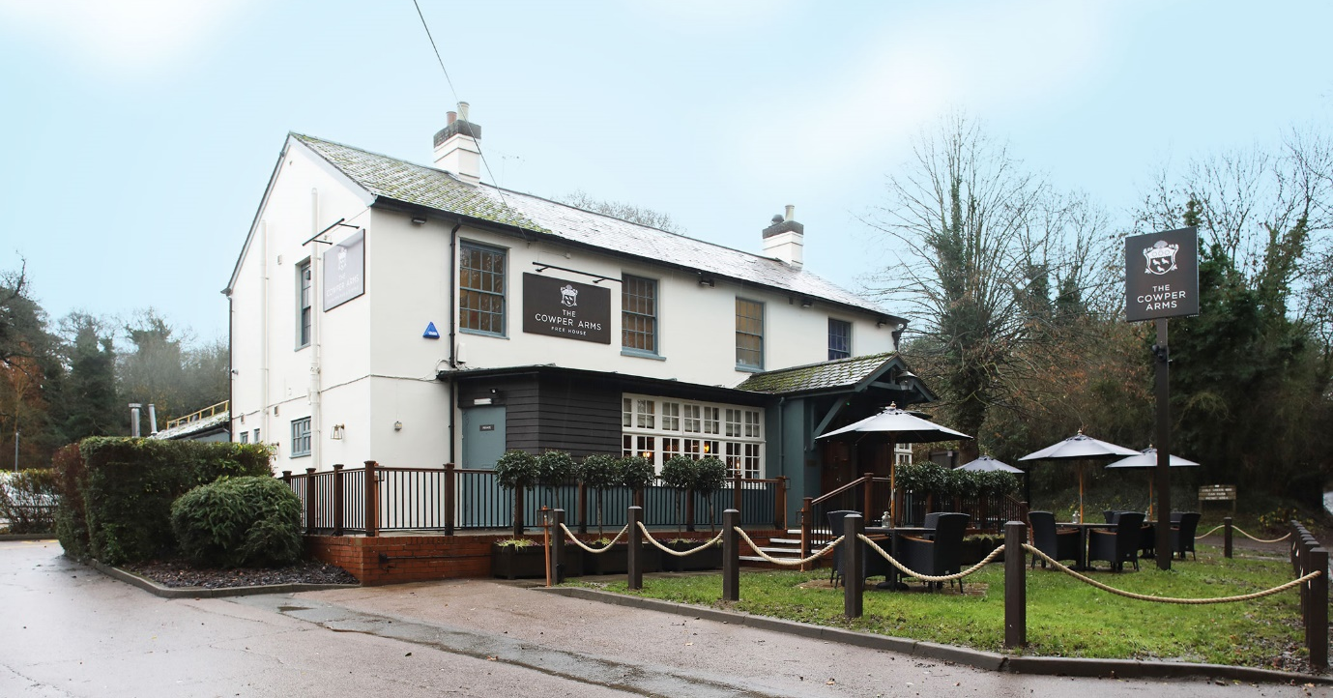
Many will remember the location from two of our recent Road-Runs
All are welcome from 6.30pm, park at the top of the large car park. The Cowper Arms has an excellent selection of foods and lots of different beers.
I look forward to seeing you there on Tuesday week

Richard Edgell redgell050@gmail.com

